Lab 4 - Bayesian Networks

# Smelly Doors

* 1. How likely is it that the room contains a monster?  
     **Answer**: The probablity is 53.3%  
     **Nodes**: [Monster] -> [Smell]  
     **Probability table**:

|  |  |  |
| --- | --- | --- |
|  | Smelly | ¬Smelly |
| Monster | 0.8 | 0.2 |
| ¬Monster | 0.3 | 0.7 |

* 1. Learned probability?  
     **Answer:** The way the NPC can learn what the probabilities are dynamically is quite simple. To find how often monsters are in the rooms, the NPC just has to take the amount of monsters he has faced so far and divide that number by the total number of rooms visited. Then to find the probabilty of smell, the NPC has to take that into account on its own so instead of total rooms, it instead divides the number of monsters that it has found by the amount of rooms it has entered while smelling a smell.

# Pirate Treasure

* 1. What is the chance that the chest will contain treasure? What is the chance that it will be trapped? Is it worth opening the chest if your life is on the line?  
     **Answer:** Nodes, connections and probability table.  
     **Nodes:** [Chest] ->[Treasure]  
     **Probability table:**

|  |  |  |
| --- | --- | --- |
|  | Treasure | ¬Treasure |
| Chest | 0.5 | 0.5 |
| ¬Chest | 0 | 1 |

**Nodes:** [Treasure] ->[Trapped]  
**Probability table:**

|  |  |  |
| --- | --- | --- |
|  | Trapped | ¬Trapped |
| Treasure | 0.8 | 0.2 |
| ¬Treasure | 0.4 | 0.6 |

**Nodes:** [Trapped] ->[Trapped]  
**Probability table:**

|  |  |  |
| --- | --- | --- |
|  | Locked | ¬Locked |
| Trapped | 0.7 | 0.3 |
| ¬Trapped | 0.3 | 0.7 |

2.2 What is the probability that a locked chest containst treasure

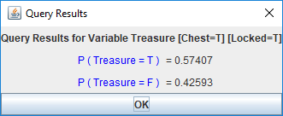

2.3 What is the probability that a locked chest is trapped

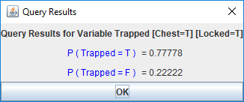

2.4